<https://linuxize.com/post/how-to-install-ffmpeg-on-centos-7/>

The RPM Fusion repository depends on the EPEL software repository. If the EPEL is not enabled on your system, enable it by typing:

sudo yum install epel-release

Copy

Next, enable the RPM Fusion repository by installing the rpm package :

sudo yum localinstall --nogpgcheck https://download1.rpmfusion.org/free/el/rpmfusion-free-release-7.noarch.rpm

Copy

Once the repository is enabled, install FFmpeg:

sudo yum install ffmpeg ffmpeg-devel

Copy

Verify the FFmpeg installation by checking its version:

ffmpeg -version

Copy

At the time of writing this article, the current version of FFmpeg available in the RPM Fusion repository is 3.4.7:

ffmpeg version 3.4.7 Copyright (c) 2000-2019 the FFmpeg developers

built with gcc 4.8.5 (GCC) 20150623 (Red Hat 4.8.5-39)

...Copy

That’s it. FFmpeg has been installed on your CentOS machine and you can start using it.

service --status-all

chkconfig –list

You can use [FFserver](http://trac.ffmpeg.org/wiki/Streaming%20media%20with%20ffserver) to stream a video using RTSP.

Just change console syntax to something like this:

ffmpeg -i space.mp4 -vcodec libx264 -tune zerolatency -crf 18 http://localhost:1234/feed1.ffm

Create a ffserver.config file ([sample](http://ffmpeg.org/sample.html)) where you declare HTTPPort, RTSPPort and SDP stream. Your config file could look like this (some important stuff might be missing):

HTTPPort 1234

RTSPPort 1235

<Feed feed1.ffm>

File /tmp/feed1.ffm

FileMaxSize 2M

ACL allow 127.0.0.1

</Feed>

<Stream test1.sdp>

Feed feed1.ffm

Format rtp

Noaudio

VideoCodec libx264

AVOptionVideo flags +global_header

AVOptionVideo me_range 16

AVOptionVideo qdiff 4

AVOptionVideo qmin 10

AVOptionVideo qmax 51

ACL allow 192.168.0.0 192.168.255.255

</Stream>

With such setup you can watch the stream with i.e. VLC by typing:

rtsp://192.168.0.xxx:1235/test1.sdp

ffmpeg -re -f mp3 -i sender.mp3 -acodec libmp3lame -ab 128k -ac 2 -ar 44100 -f rtp rtp://10.14.35.23

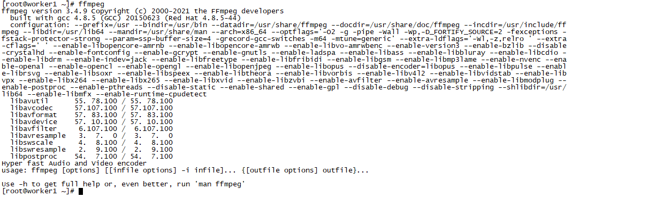

#ffmpeg –i /opt/PhuongBuonNamCu-BaoNguyen-7136033.mp3

https://viblo.asia/p/ffmpeg-va-20-cau-lenh-co-ban-xu-ly-am-thanh-hinh-anh-va-video-naQZRYBAKvx